**Lab 8**

**OBJECTIVE: Introduction to Image Processing**

Lab Tasks:

**Assignment 1: Apply Brightness**

1. Load an image.

2. Increase the brightness of the image.3. Display the original and augmented image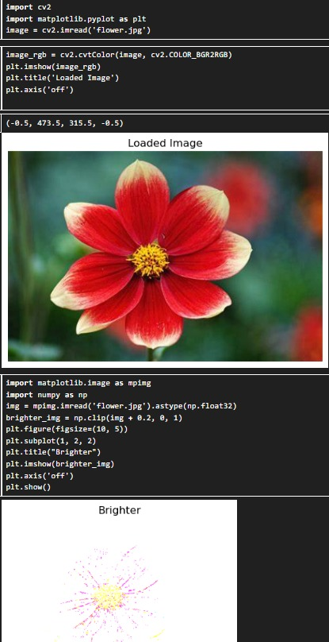

**Assignment 2: Apply Another Edge Detection Technique**

1. Load an image.

2. Convert the image to grayscale.

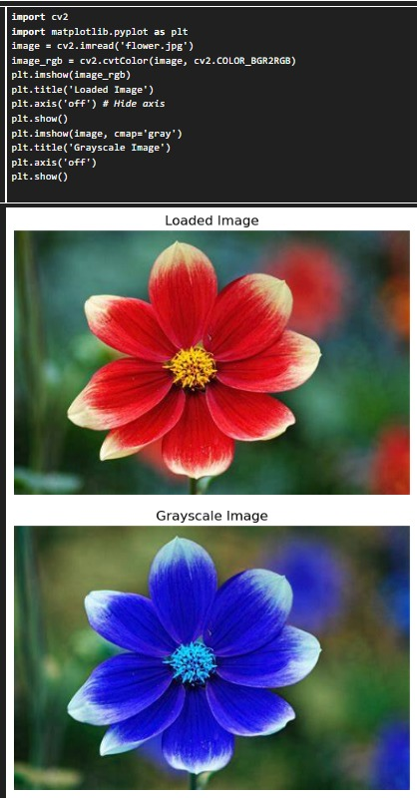

3. Apply the Sobel edge detection technique to the grayscale image.

4. Display the original grayscale image and the Sobel edge-detected image.

5. Hint: Use the cv2.Sobel function in OpenCV to apply the Sobel operator

